**Phase Development-1 Report**

**For**

**An Interactive e-learning Platform for Learners**

**Version 1.0 approved**

**Prepared by:**

**Technotuners**

**Nikitha Rao Jakati**

**Sivani Akkem**

**Haritha Talupula**

**Umarani Vemula**

**Jyothirmayee Manne**

**Sai Rukma Reddy Gade**

**Lakshmi Dheeraj Oruganti**

**Sai Krupanand Reddy Bakaram**

**Date Created: 10/24/2022**

**Table of Contents**

1. Requirements..................................................................................................... .. ……  3

1.1 Homepage of the system……………………………………………………………… 3

1.2 Account Registration for Tutor and Student…………………………………………. 3

1.3 Login for both Tutor and student………………………………………………………. 3

1.4 Forgot Password……………………………………………………………………… 3

1.5 Profile Information…………………………………………………………………… 3

1.6 Setting the project……………………………………………………………………… 3

2. UML Diagrams .....................................................................................................  4

2.1 Class Diagrams ........................................................................................................ 4

2.2 Sequence Diagram...........................................................................................................5

2.3 Use Case Diagram......................................................................................................... 8

3. Test Cases......................................................................................................................... 9

4. User Manual..................................................................................................................... 11

5. Peer Review feedback.................................................................................................... 11

6. Implementation Plan........................................................................................................ 12

7. Challenges for phase1 implementation.......................................................................... 12

 Team Member Contribution Table.................................................................................... 13

**Revision History**

|  |  |  |  |
| --- | --- | --- | --- |
| **Name** | **Date** | **Reason For Changes** | **Version** |
| Nikitha Rao J | 24/10/2022 | Initial Copy | **1** |

**1. Requirements**

**1.1 Homepage of the system:**

Home page displays login and registration options for both students and tutors. Here, the login page is the same for students and tutors. Registration is different for both. It will display 2 options, one for students and the other for tutors, for registering.

**1.2 Account registration for both Tutors and Student:**

To access this learning platform Students and tutors must register with their details for the first time. From the next time onwards, he/she can login to the website using their credentials. Students who want to register their account must provide some details like their First Name, Last Name, Roll Number, Student ID, Username, Email Address, and Password. Tutors must provide First Name, Last Name, Email, Username, Password.

**1.3 Login for both Tutors and Student:**

1. Every user must use their username and password to login into the system.

2. After login, the student can view the list of courses available and can enroll into their respectable courses.

3. After login, the teacher can be able to view his profile and dashboard for the course he is tutoring.

**1.4 Forgot Password:**

We currently include a "forgotten password" feature in this deliverable, but we are unable to complete this submission due to time constraints.We will add this feature in the next deliverable. As this will not impact most of the other functionalities.

**1.5 Profile Information :**

In our project, we’ve developed a feature where users can add their profile information such as First name, Last name, Username, Email ID. So, we’re planning to incorporate these changes dynamically in the next development phase i.e, phase 2.

**1.6 Setting the Project:**

First, we need to install a python 3.7 or higher version. Then install a package called pip inside it.

Set the path and environment variables and execute the following commands.

`pip -r requirements.txt && python manage.py makemigrations $$ python manage.py migrate && python manage.py runserver`

**2. UML Diagrams**

**2.1 Class Diagram**

The ER model is widely regarded as a premier illustration of an enterprise-level conceptual data model. The notion behind this paradigm and its numerous variations is used by a wide variety of database design tools to facilitate the development of cutting-edge database programs. The concept of an E-Learning Management System Entity is depicted in this ER (Entity Relationship) Diagram. The database tables that make up an E-Learning management system can be visualized in the form of an entity-relationship diagram, which displays the interconnections between the various parts of the system, such as students, fees, courses, and training.

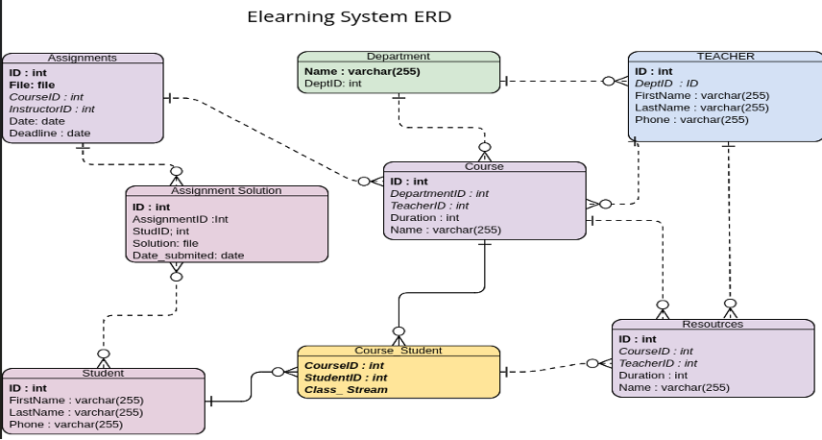

**2.2 Sequence Diagram**

This is the UML sequence diagram of the E-learning management system which shows the interaction between the objects of AccountLogout, AddCourse, Login, ResourcesAdd, ResourcesDownload, and Sign Up among students and lecturers. The sequences of each action is shown below:

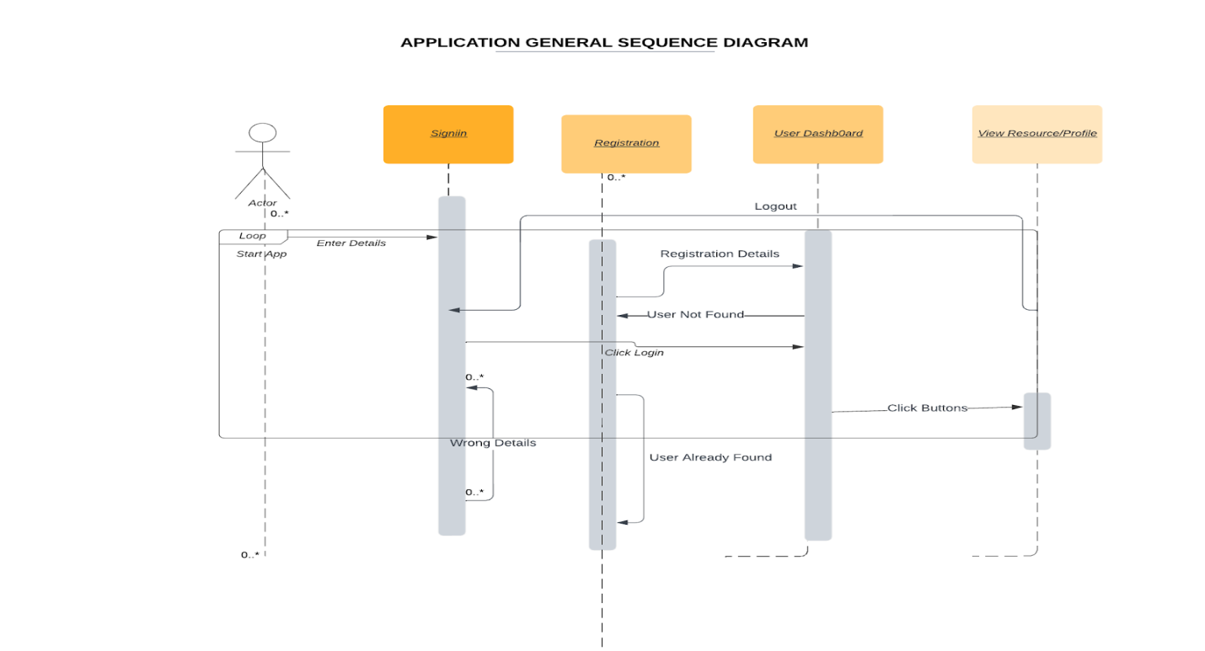

**AccountLogout**

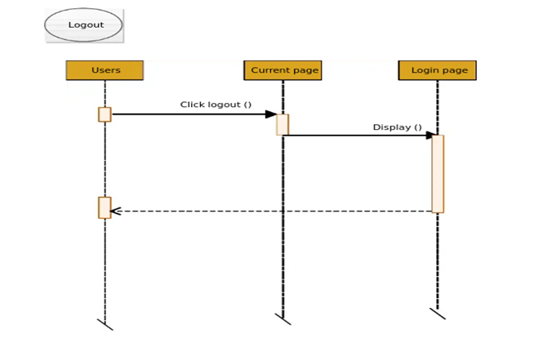

**Add Course**

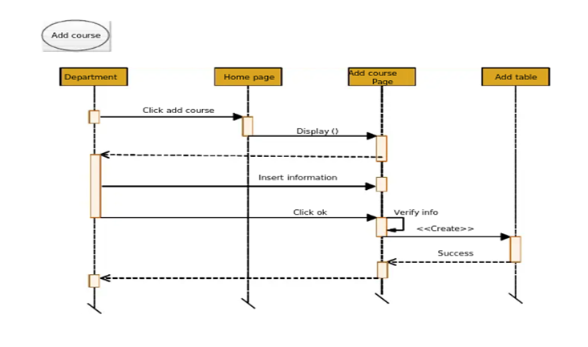

**Login**

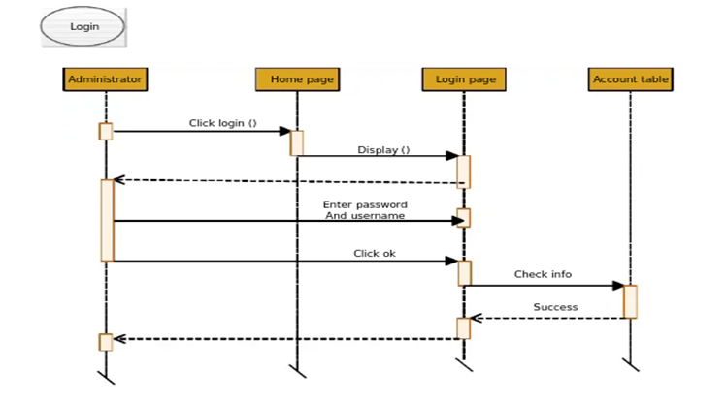

**SignUp**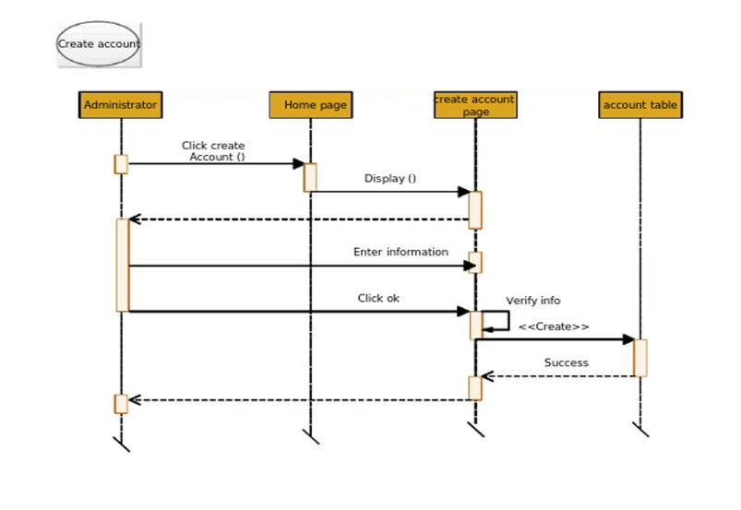

**2.3 Use Case Diagram**

Use case diagrams are graphical representations of the relationships between modules in an e-learning management system. An e-learning management system's system needs are discovered, clarified, and organized using a method similar to that depicted above. A Super Admin, System User, Teacher, and Student all play important roles in an E-Learning Management System, as shown in this Use Case Diagram. These people are in charge of executing the many different use cases that make up an e-learning platform, including: Manage Course, Manage Students, Manage Scheduling, Manage Fees, Manage Timelines, Manage Training, Manage Subject, Manage Users, and Full E-Learning Management System Operations.

Use Diagram for this deliverable i.e, development phase 1

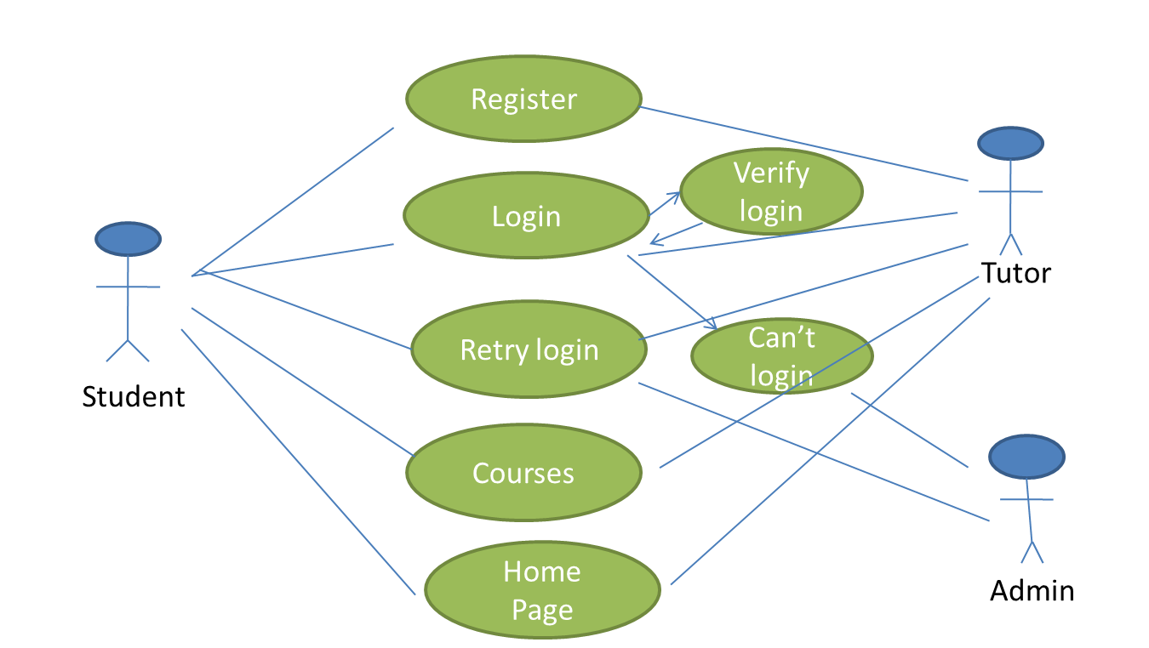

Use Diagram for entire project

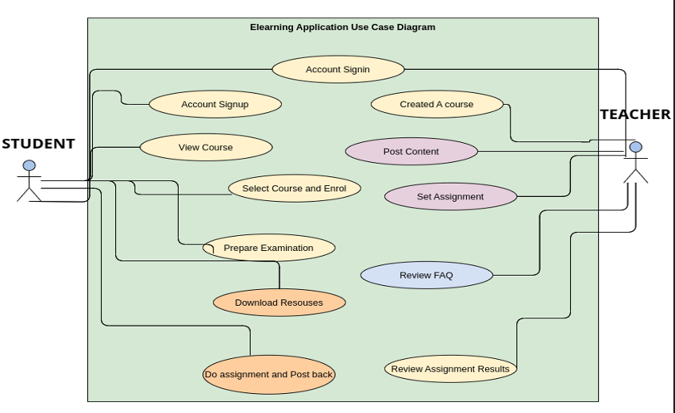

**3. Test Cases**

|  |  |  |  |  |
| --- | --- | --- | --- | --- |
| **S.No** | **Test Case** | **Pre-Condition** | **Post-Condition** | **Result** |
| 1 | User Registration | Users will be on the registration page. User will fill the form by providing unique username, email, contact and other details depending on whether he is a teacher or a student | On submitting the form, user data will be stored in the database and can now login with the username key. | Pass |
| 2 | Login | User must be able to see a form prompting him to provide his unique username key for the user and submit it. Otherwise create a new account where the user will be on test (1). | On submitting the form, if credentials are correct, the user will be redirected to the dashboard of the app. Otherwise, a message of wrong credentials returned | Pass |
| 3 | Dashboard Navigation Click | None | My courses, assignments |  |
| 4 | View profile | Teacher/student will be able to view his/her profile. Users can now change details. | User changed details are updated and new details returned on the page | Pass |
| 5 | Homepage Verification | In this, Teacher/Student can be able to see the homepage for the platform. | User can view the details of all the different courses that are provided in the platform. | Pass |

**4. User Manual**

To run this application, do the following;

  - Make sure you have installed python3.8 or higher

  - Install pip3

  - After installing the above, run the following command.

`pip -r requirements.txt && python manage.py makemigrations $$ python manage.py migrate && python manage.py runserver`

- The above is a 4 command line which you can split into individuals if you want.

**5. Peer Review Feedback**

Meeting on Tuesday, 10/11, 12:00pm-01:00pm

Purpose: Technotuners Review with Group 12SE

* Discussed the project idea and explained the features of the project and how it works.

**Suggestions given by the partner group:**

* Rating the professors:

They suggested us to add a star rating to the instructors by the students, so that other students can know the feedback before enrolling into the course.

* Assessment of tests:

They suggested us to provide tests at the end of every module, which will help students to improve their performance and to know how much they understood the lecture. At the end of tests answers will be provided.

* User friendly:

They  provided us with the feedback that they were able to test the system's functionalities in order to determine whether or not it satisfies the requirements that the customers have specified. Due to the fact that the system is quite user friendly, the vast majority were able to navigate it without any problems whatsoever.

**Accepted:**

* Rating the professors
* Assessment tests

**Rejected:**

The only suggestion given is Rating the professors and Assessment tests, there is nothing to reject.

**Discussion with Group 12SE:**

* Can students interact with professors?

Answer: Yes, a chat functionality is available for the students during the class section and after the class section so that students can clear their doubts with the professors and this chat is available both in public and private, as it will be helpful to other students as well.

**5. Implementation Plan :**

 In this project, we’d be implementing it in an incremental way where we have divided the features that should be implemented into different development phases.

Development Phase 1 :

In this phase, we’d be implementing the Login, Registration pages of our e-Learning platform. The User Interface part of the plan would be done both for student and the tutor. The home page design is completed and user can be able to see the dashboard.

Development Phase 2 :

In this phase, we’d be implementing the features or functionalities related to the tutor and the student. The tutor functionalities includes adding of assignments, classrooms, editing them, etc.

Development Phase 3 :

In this phase, we will implement the functionalities of the student. It includes the features such as attempt the quizzes, go through the lessons, etc. We’ll be testing the remaining features and will establish the database connections.

**7. Challenges for phase 1 Implementation :**

In this phase, we have implemented the features such as Login page, Registration Page, Homepage.

So, we’ve faced a few issues in developing them. The coding part for developing the UI page for both registration and Login was a difficult task. The connection establishment for database has been a challenge where we need to setup python.

**Team Member Contribution Table**

|  |  |  |  |
| --- | --- | --- | --- |
| **Name** | **Contributions** | **Overall Contribution(%)** | **Notes** |
| Nikitha Rao Jakati | Backend Developer/  Testing | 12.5 | HTML  (UML diagrams) |
| Umarani Vemula | Backend Developer | 12.5 | Testing, documentation |
| Sivani Akkem | Database  Administrator | 12.5 | Database Model,  UML diagrams |
| Haritha Talupula | UI Developer/ Testing | 12.5 | CSS, Bootstrap  (UML diagrams) |
| Jyothirmayee Manne | UI Developer | 12.5 | JavaScript  documentation |
| Sai Rukma Reddy Gade | Backend Developer/ Testing | 12.5 | HTML  documentation |
| Lakshmi Dheeraj Oruganti | Database  Administrator | 12.5 | Database model  documentation |
| Sai Krupanand Reddy Bakaram | UI Developer/ Testing | 12.5 | Python, JavaScript,  Test cases |